H.T No
Regulations:
A15


Sreenidhi Institute of Science and Technology
(An Autonomous Institution)
Code No: 5K601 Date: 27-May-2019 (FN)

B.Tech III-Year II-Semester External Examination, May/June-2019 (Regular)
Design of Steel Structures(civil)

Time: 3 Hours Max.Marks:75

Note: a) No additional answer sheets will be provided.
b) All sub-parts of a question must be answered at one place only, otherwise it will not be valued.
c) Missing data can be assumed suitably.

Part - A Max.Marks:25

Answer all QUESTIONS.

1. | Define strength of a joint, efficiency of a joint. | [3M]
2. | Sketch the different forms of compression members. | [3M]
3. | How do you calculate the net sectional area of angles and plates in tension? | [3M]
4. | Differentiate rolled steel beams and built-up beams. | [3M]
5. | List few I-sections used for Purlins. | [3M]
6. | What are the different types of loads acting on plate girders? | [2M]
7. | Define Web-buckling. | [2M]
8. | What are the modes of failure in Tension members? | [2M]
9. | Difference between simple slab base and gusseted base. | [2M]
10. | Explain briefly the elements in a plate girder. | [2M]
Part – B Max.Marks:50
ANSWER ANY FIVE QUESTIONS. EACH QUESTION CARRIES 10 MARKS.

11. |  | Design a joint when two flats of Fe 410 grade steel each 220mmx10 mm are to be jointed using 20 mm diameter 4.6 grade bolts to form a lap joint and to support a factored load of 300kN. | [10M]
12. |  | An ISA100x100x8mm is used as a strut. The effective length is 4m. Calculate the strength when it is connected by  i) one bolt at each end.  ii) two bolts at each end.  iii) welded at each end. | [10M]
13. |  | Design a double angle tension member to carry an axial tension of 480KN, using steel of yield stress 250N/mm² and ultimate stress 410 N/mm².the effective length of the members is 6m. The angles are to be connected on either side of 12mm gusset plate by fillet welds. | [10M]
14. |  | Design a simply supported beam which is laterally supported through out with an effective span of 8.3m with a factored load of 26 KN/m including self-weight. Check for web buckling, web crippling and deflection. | [10M]
15. | a) | Determine the wind pressure to be considered on sloping roof from the following data  i). The building is located in Pondicherry.  ii). Span of the roof 12m.  iii). Pitch of the roof 1/4.  iv). Height of the eaves above the ground is 6m.  v). The maximum dimension is more than 55m.  vi). Assume normal permeability. | [6M]
 | b) | Explain the types of roof trusses with neat sketches. | [4M]
16. |  | Design a slab base for a column ISHB300@0.577kN/m carrying an axial factored load of 800kN. Provide welded connection between column and base plate. Assume M40 concrete for foundation. | [10M]
17. |  | Design a built up column with two channels placed back to back. The column is hinged at both the ends. Effective length is 10m and factored axial load is 1080 KN. | [10M]
18. |  | Determine the maximum value of factored load ‘P’ which can be carried safely from the bracket plate bolted to a vertical column as shown below. Use M18 bolts of grade 5.6  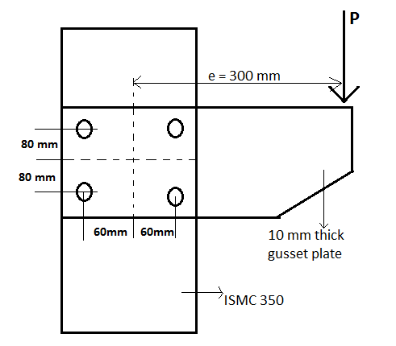 | [10M]

-- 00 -- 00 –

